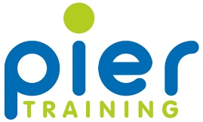
Modern Slavery and Human trafficking Policy

Our commitment to you:
Pier Training is committed to understanding all potential modern slavery risks relating to its business and to ensuring the business and its supply chains are free of modern slavery and human trafficking.
We acknowledge our responsibility to take a robust approach to slavery and human trafficking and to comply with all principles of the Modern Slavery Act 2015.
The Objective of the Policy:
Modern slavery is a criminal offence under the Modern Slavery Act 2015. Modern slavery can occur in various forms, including servitude, forced or compulsory labour and human trafficking, all of which have in common the deprivation of a person’s liberty by another in order to exploit them for personal or commercial gain. This policy sets out how Lifetime aims to prevent opportunities for modern slavery to occur within the Company or any areas of our supply chain
Responsibilities:
The responsibility for the prevention of modern slavery and for ensuring the policy and its implementation complies with our legal and ethical obligations, rests with the executive team. The Senior Management Team are responsible for the implementation of this policy and for ensuring those who report to them understand and comply with this policy. This policy can be accessed by all employees on SharePoint under:
This policy applies to all Pier Training employees as well as to all suppliers and business partners.
Organisation and Structure:
Pier Training is a Training Provider based in the UK and we offer Apprenticeship programmes Nationally across a range of business sectors.We are a forerunner in delivery of healthcare and management programmes, we are driven to support businesses with all aspects of training and development with a wealth of resources.
Pier Training work in the following sectors:
- Functional Skills
- Healthcare
- Leadership & Management
- Learning & Development
- Customer Service
- Business Administrator
The scope of our business is within the United Kingdom only and given the nature of our supply chain, we do not deem any particular activities or areas we operate in, as high risk in relation to modern slavery.
Policies:
Pier Training has in place the following policies that describe our approach to the identification of modern slavery risks and steps to be taken to prevent slavery and human trafficking in its operations.
- Whistleblowing Policy
- Corporate / Social Responsibility
- Employee Code of Conduct
- Supplier Code of Conduct
- Safeguarding Policy
- British Values
- Prevent
Pier Training are confident from our due diligence that there is no evidence of modern slavery or human trafficking in our business. The business undertakes due diligence when considering taking on new suppliers or forming relationships with members of our supply chain and regularly reviews our existing supply chain.
If any supplier were to not meet our standards as set out in this policy and our code of conduct then Pier Training would consider invoking sanctions and termination of the business relationship
Monitor and review:
- All team members will read and understand the policy and where appropriate, receive additional training.
- All suppliers will provide such co-operation and information that Pier Training reasonably requires in order to confirm compliance with our code of conduct, including, but not limited to, providing written confirmation as to compliance with the Pier code of conduct, on request and allowing Pier training to carry out (or commission others to carry out) compliance checks and audits.
Review:
This policy, along with all other policies will be subject to a periodic review – the next review will be due in August 2019

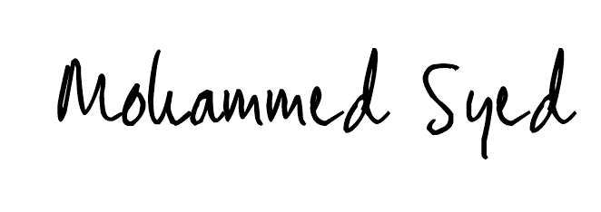
Signed: Date: 12/09/2018

Position: Managing Director

